Technical Support Documentation.

Product Name: **Symphony**

Fig(1)

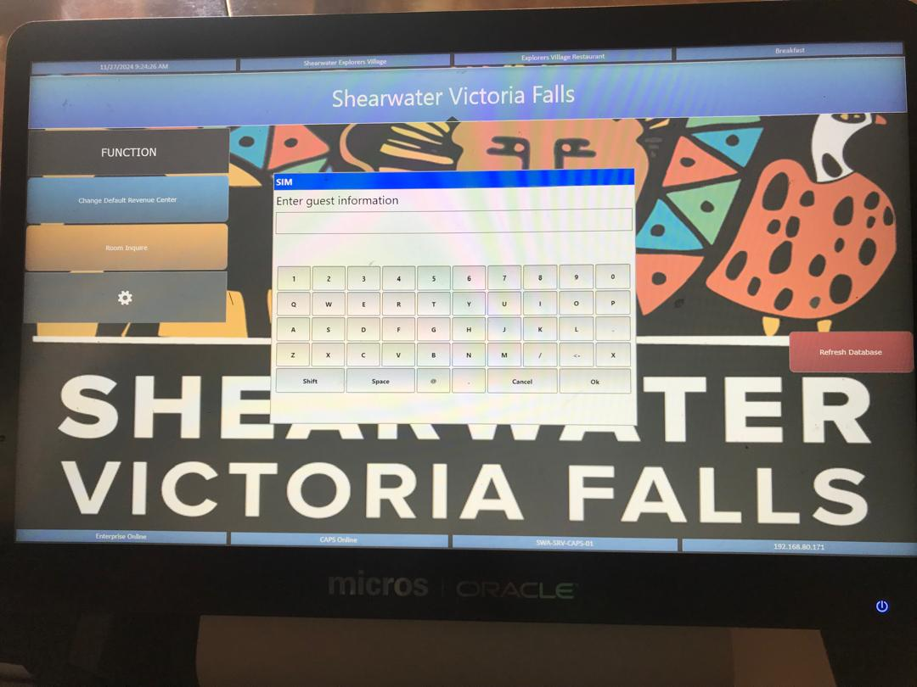

Press room enquire, press M then you press ok and the interface below (Fig(2)) should pop up and that confirms that the system is online and working perfectly.

Fig(2)

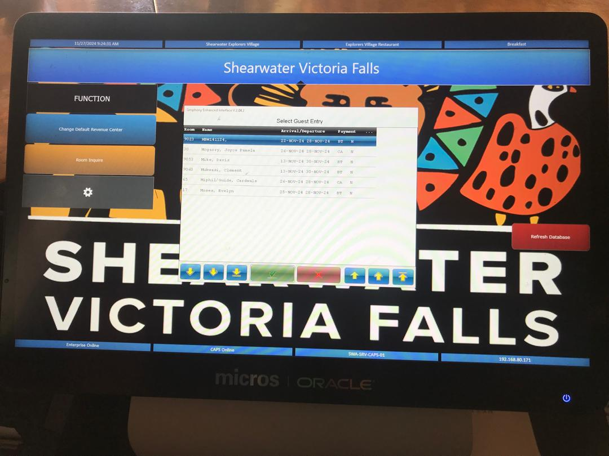

The last important step to take is to refresh the database by pressing the red “refresh database” button on your right in the above interface(Fig(2)).

However, if you are unable to get to the above interface pressing room enquire, it means the two opera applications in the back-office computer are either closed or they need to be restarted or in some instances these applications will be running in the wrong user account(reception).

*NB* Opera applications should only be running in the explorers village1 user account and they should be running as an administrator.

Fig(3)

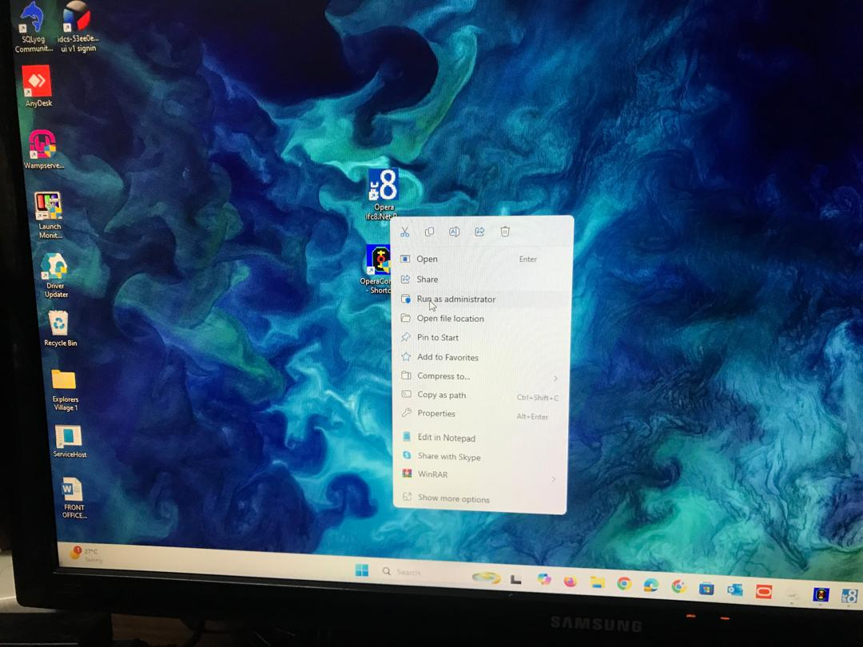

After running them as an administrator, you should see the following interfaces when they are working perfectly. The interface in fig(4) should always have a green color at the top, if it’s red then it means something needs attention and the opera will be down.

Possible Fixes:

Check if the opera application is running in the correct user account( Explorers Village1), otherwise close the application in the reception user account and run it as an administrator in the correct account.

Fig(4)

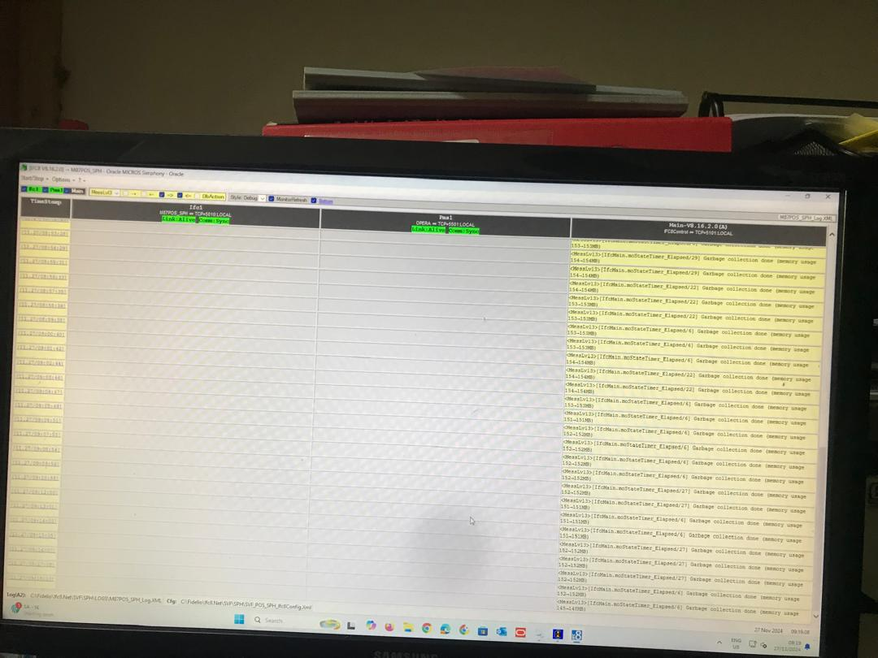

Fig(5)

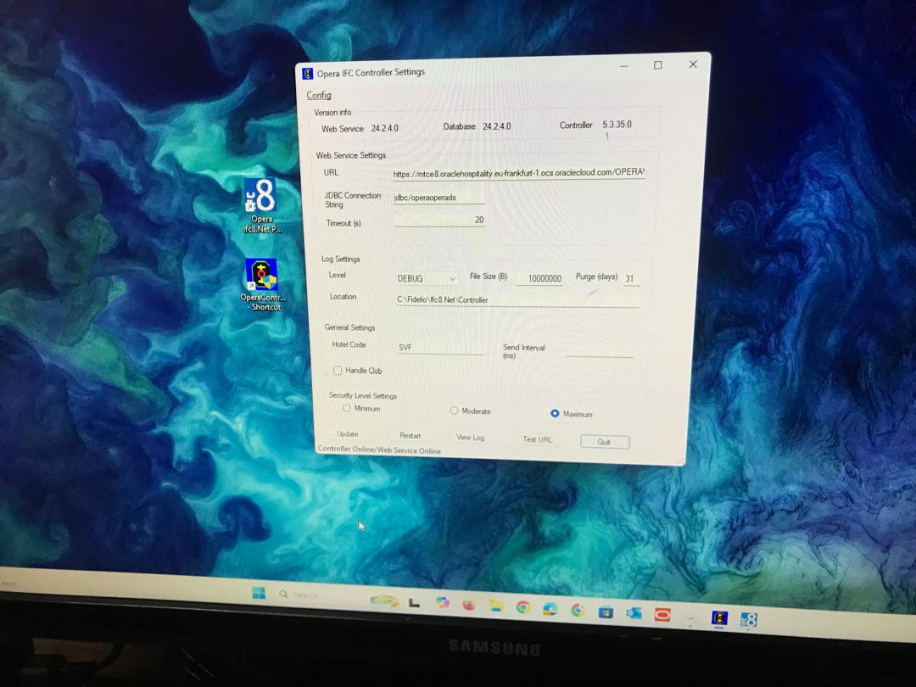

Possible Error No: 2. Failure to close bills (error code 9500)

Product Name: GAAP Printer.

On the Duties Manager’s Machine, open the GAAP application and make sure its executing and if it is, then the interface below (Fig(6)) should pop up.

Fig(6)

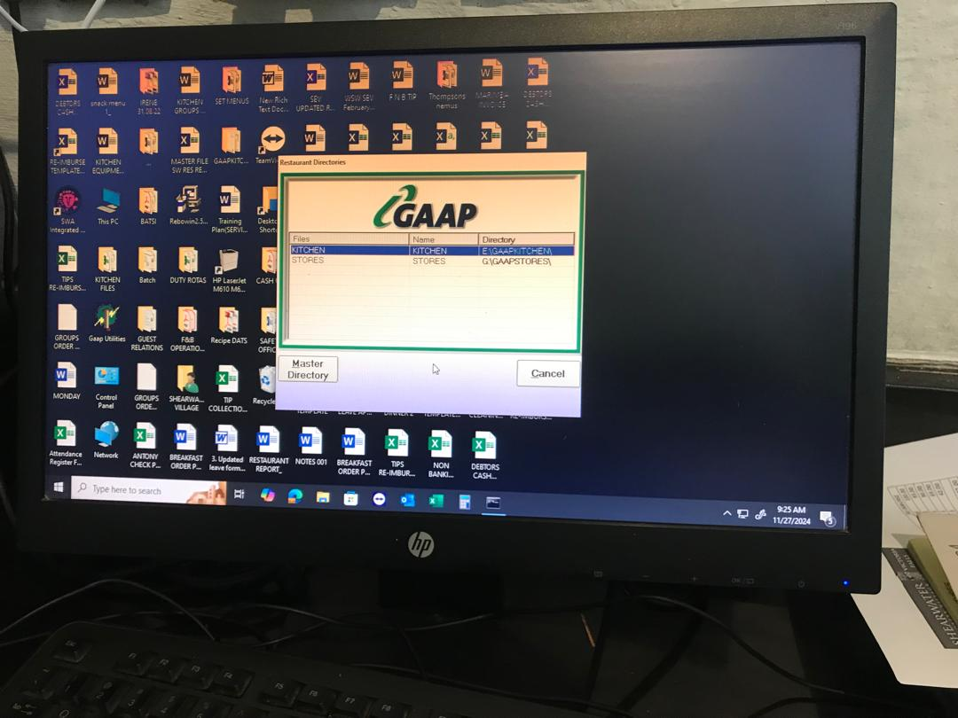

**Prerequisites:**

The main GAAP machine in the IT office(Fig(7)) should be on, if not then the GAAP application on the duties manager’s machine won’t execute.

Fig(7)

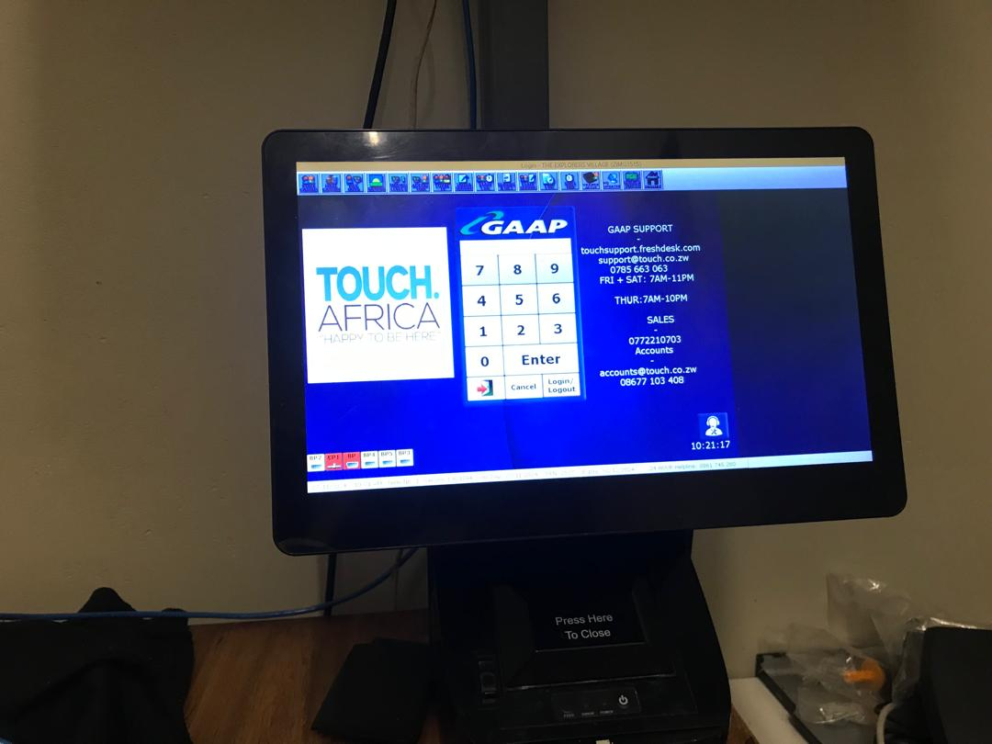

Product Name: Kitchen Printer

Every day in the morning you have to reboot the printer in the kitchen and perform a self-test on the printer and you do that by following steps the below:

Step 1: Turn off the printer

Step2: Turn it back on

Step3: Long Press the self-test button with an arrow entangled in a circle *(see Fig(8)),* to print out the self-test receipt

Step4: In the receipt, check the mac address(FB-25-51-7F-d7-8E, then the IP Address(129.168.80.32, Gateway(192.168.80.254), and the subnet mask(255.255.255.0) (*see Fig(9)).*

Fig(8)

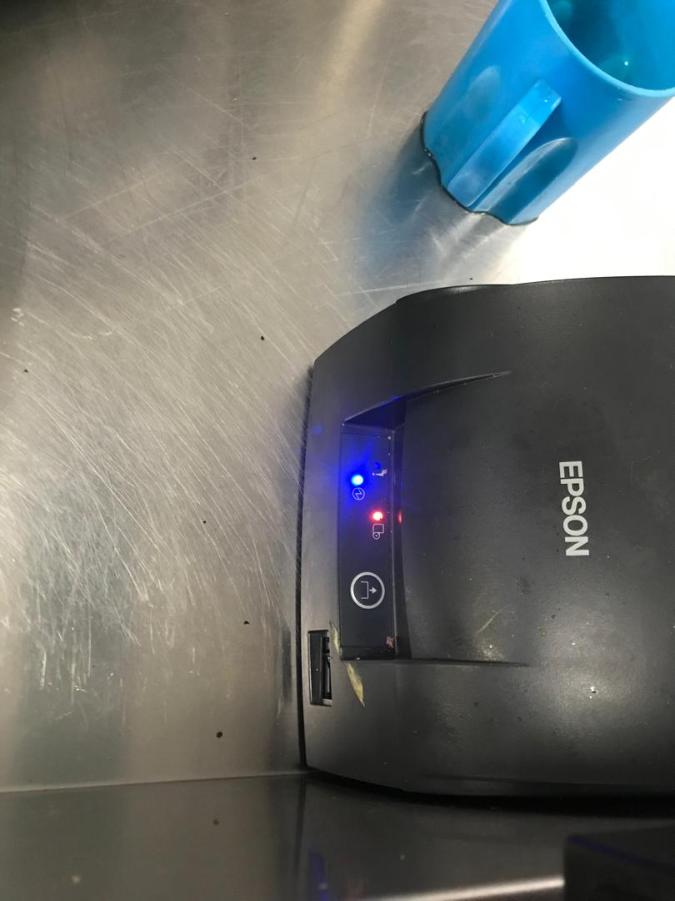

Fig(9)

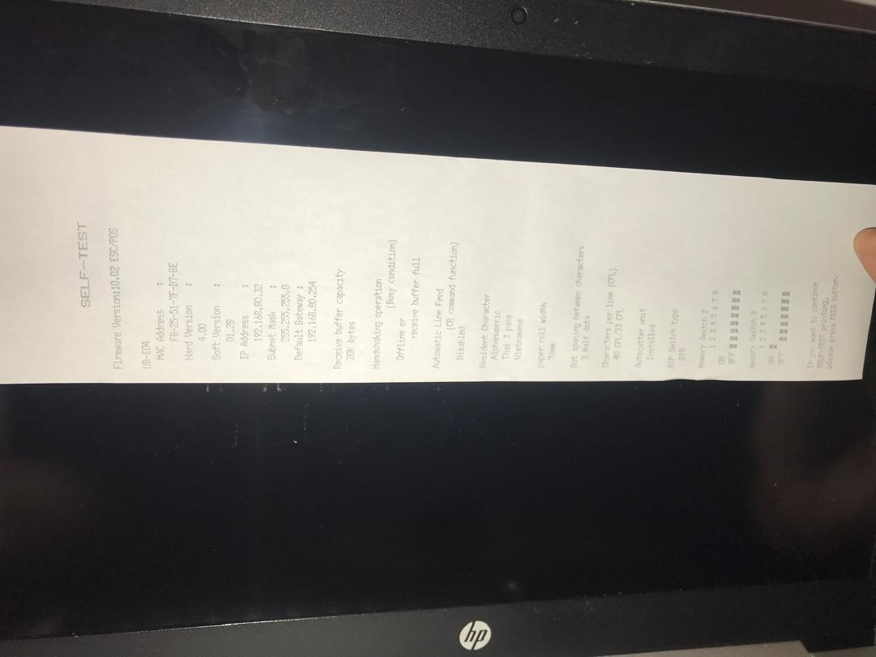

Product Name: IBMS

Possible errors:

Unable to connect to any of the specified mySql hosts

Possible Fixes:

Check if it’s connected to the right database server (102.177.75.12), by following the steps below: Go to “This Pc” – Users- AppData-Local-Apps-2.0-Data-Take the most recent-open with noted pad-highlight the database server address-press ctrl + h to replace all-save.

Check if they are using the most recent version of POS.

Try pinging 102.177.75.12 and if it’s down tracert it and see where exactly its failing.

We do this so that we fix the root cause of the disconnect from 102.177.75.12.

If everything seems to be okay but you are facing the error, restart the pos system and run it again. *(see Fig(10)).*

Fig(10)

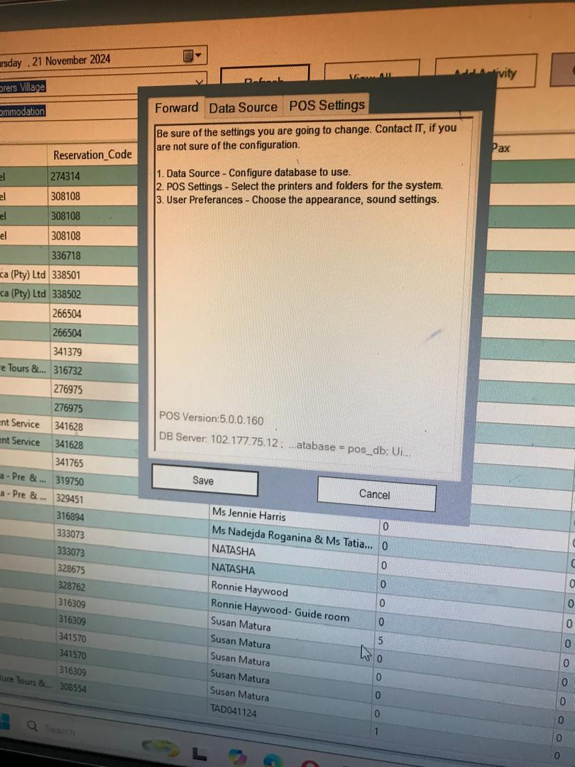

Product Name: Physical Printers in the Hotel.

Possible Problems:

Error when sending printing command jobs.

Possible Fixes:

Go to printers and scanners

Navigate to the printer that you are currently using.

Right click and remove the printer, then add it back on.